ASSIGNMENT - 3

|  |  |
| --- | --- |
| Date | 07 October2022 |
| Name | SARANBALAJI A.J |
| Team ID | PNT2022TMID26293 |
| Roll No | 211519205144 |

1. **Create a bucket in cloud Account:**

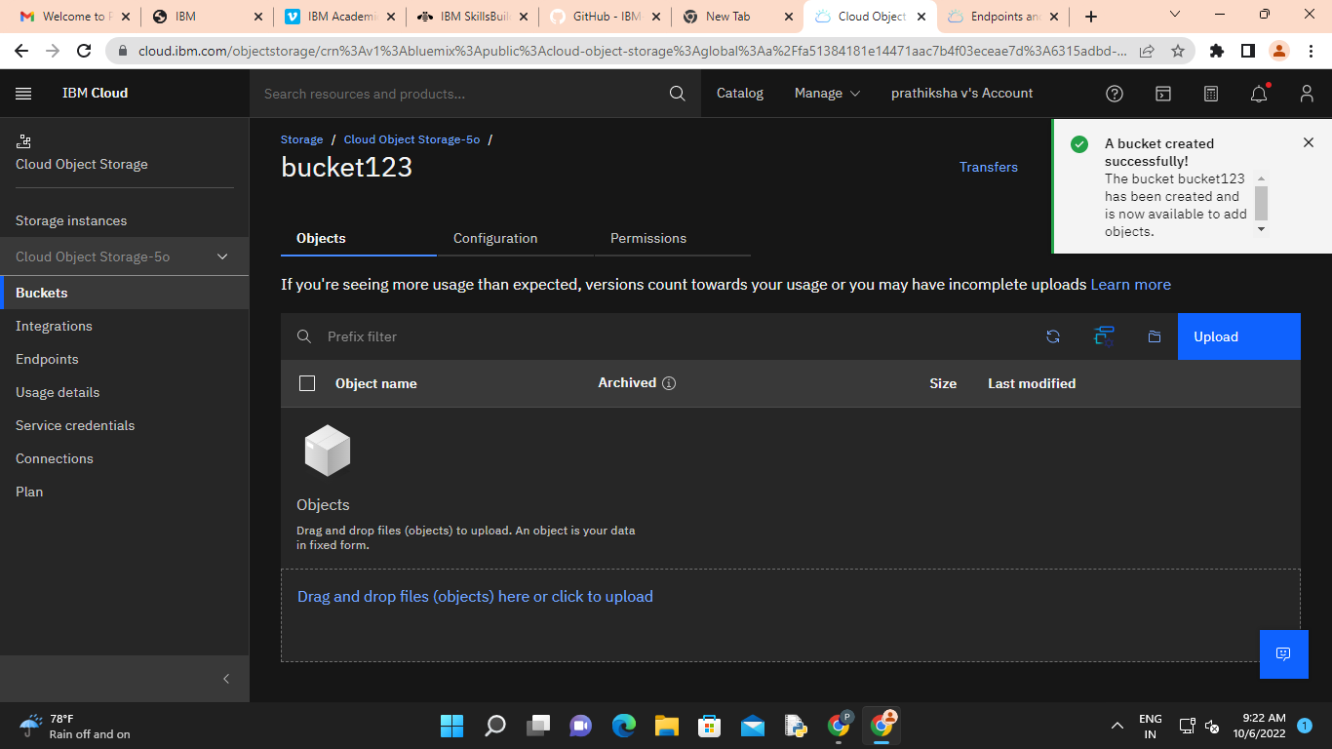

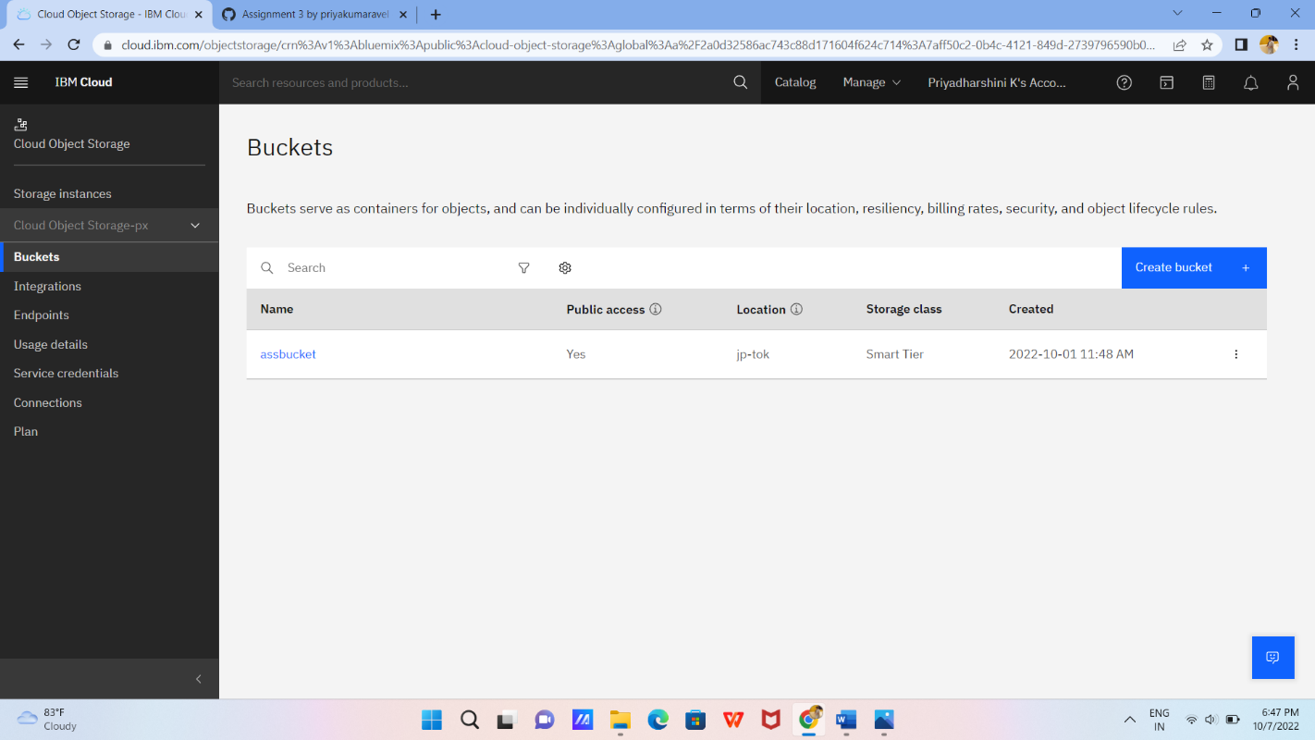

Link: https://cloud.ibm.com/objectstorage/crn%3Av1%3Abluemix%3Apublic%3Acloud-object-storage%3Aglobal%3Aa%2F2a0d32586ac743c88d171604f624c714%3A7aff50c2-0b4c-4121-849d-2739796590b0%3A%3A?paneId=manage